Project CM

Version 1.1

Revision History

|  |  |  |  |
| --- | --- | --- | --- |
| Date | Version | Description | Author |
| 17/Oct/2013 | 1.0 | Initial UC description | Storm Cloud Development |
| 22/Oct/2013 | 1.1 | Updated diagrams  Inserted Cucumber code  Added Mockups | Storm Cloud development |
|  |  |  |  |
|  |  |  |  |

Table of Contents

1. Use-Case manage mail accounts 4

1.1 Brief Description 4

1.2 Stored data 4

1.2.1 Overview 4

1.2.2 Description 4

2. Flow of Events 5

2.1 Screen Flow 5

2.2 Use Case Flows 6

2.2.1 Show all contacts (List View) 6

2.2.2 Show single contact (View Single) 6

2.2.3 Create new contact (Create) 7

2.2.4 Edit contact (Edit) 8

2.2.5 Delete contact (Delete) 9

3. Special Requirements 10

4. Preconditions 10

4.1 Account 10

5. Postconditions 10

5.1 Account 10

6. Extension Points 10

# Use-Case manage mail accounts

## Brief Description

This use case describes how a user can manage his mail accounts. This means not to provide him a mail account, but to let him administrate the mail accounts he wants to access with the application. He can create (add), read, update and delete mail accounts (CRUD).

## Stored data

### Overview

|  |  |  |  |  |
| --- | --- | --- | --- | --- |
| Name | Auto-assigned | Unique | Mandatory | Modifiable |
| Id | Yes | Yes | Yes | No |
| Sender Name | No | No | No | Yes |
| Email | No | Yes | Yes | No |
| Password | No | No | No | Yes |
| Retrieve Type | No | No | Yes | No |
| Retrieve Host | No | No | Yes | Yes |
| Retrieve Port | No | No | Yes | Yes |
| Retrieve SSL | No | No | Yes | Yes |
| Retrieve Authentication | No | No | Yes | Yes |
| Send Host | No | No | Yes | Yes |
| Send Port | No | No | Yes | Yes |
| Send SSL | No | No | Yes | Yes |
| Send Authentication | No | No | Yes | Yes |
| Logon Name | No | No | No | Yes |

### Description

A mail account has several data which must be stored. First of all you need an email address where you want to receive / send mails with. Also you need a logon name and a password to logon. Both of those are obligatory when creating the account. If the user does not provide a logon name, his email address is used and without a stored password he will be asked for his password every time it is needed. Also the user has a sender name which is shown to others when he sends a mail. This is also obligatory and is replaced by the email if not provided by the user. Mandatory information is the type of the retrieval (IMAP or POP3) and the host and security data for sending and retrieving mails. The host data is the Host name and Port and security information are the SSL type to connect with and the authentication type (password, encrypted password).

# Flow of Events

## Screen Flow

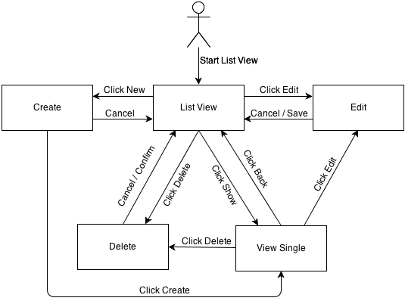

## Use Case Flows

### Show all contacts (List View)

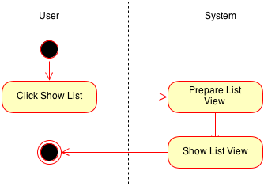

### Show single contact (View Single)

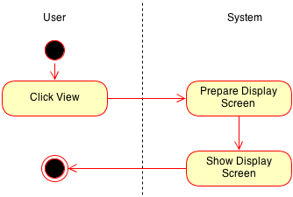

### Create new contact (Create)

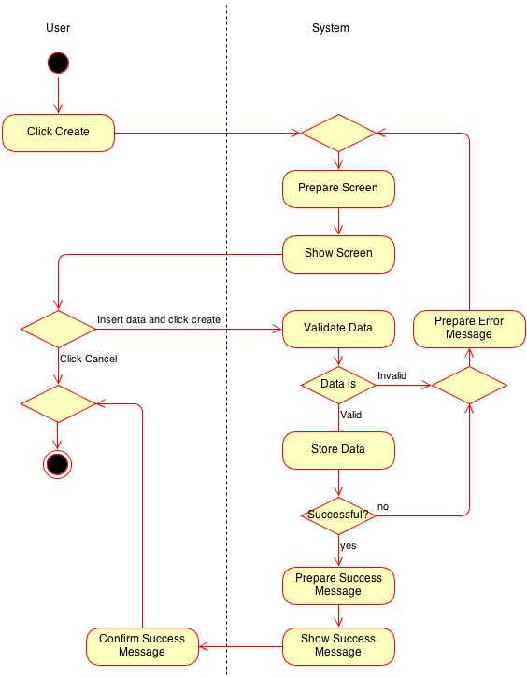

### Edit contact (Edit)

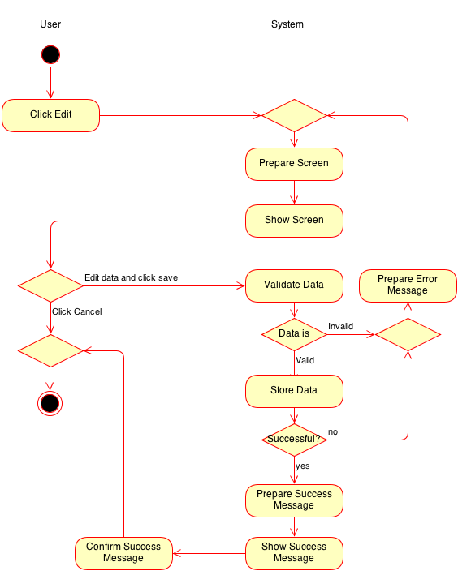

### Delete contact (Delete)

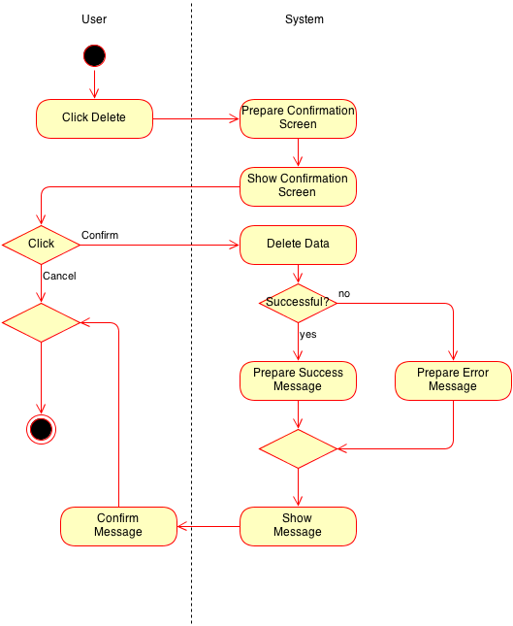

# Special Requirements

n/a

# Preconditions

## Rights

View/edit/delete/create: The user must have the rights to do the operation

## Account

Create: The email address must exist.

Create/edit: The login data must be right to use the application properly.

# Postconditions

## Account

Create/edit: The new account is successfully added / updated.

Create/edit: The user gets a verification mail to activate his account for usage.

# Extension Points

n/a